Results

## Figure 1

Relationship of bias factor $K=R^{*}/R$, linkage probability $P_{L}$, and vaccination reporting probability $r_{V}$, given $P\left(V\right)=0.75$, $R=0.2$, and $N^{*}=N$.

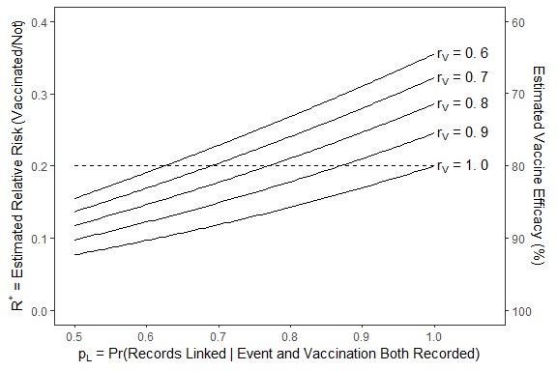

## Table 1

Simulation results with $P\left(V\right)=0.75$, $r_{D}=0.9$, $r_{V}=0.9$, and :

|  |  |  |  |  |  |  |  |  |  |
| --- | --- | --- | --- | --- | --- | --- | --- | --- | --- |
| 1.0 | 0.95 | 0.861 | 0.861 | 0.861 | 0.015 | 0.861 | 0.015 | 100.0 | 100.0 |
| 1.0 | 0.90 | 0.745 | 0.745 | 0.745 | 0.013 | 0.745 | 0.013 | 100.0 | 100.0 |
| 1.0 | 0.70 | 0.431 | 0.431 | 0.431 | 0.007 | 0.431 | 0.007 | 100.0 | 100.0 |
| 0.2 | 0.95 | 1.136 | 0.227 | 1.137 | 0.033 | 0.227 | 0.007 | 0.0 | 0.0 |
| 0.2 | 0.90 | 1.050 | 0.210 | 1.051 | 0.031 | 0.210 | 0.006 | 4.3 | 0.1 |
| 0.2 | 0.70 | 0.745 | 0.149 | 0.744 | 0.023 | 0.149 | 0.005 | 100.0 | 100.0 |

## Table 2

Simulation results with $P\left(V\right)=0.75$, $r_{D}=0.7$, $r_{V}=0.9$, and :

|  |  |  |  |  |  |  |  |  |  |
| --- | --- | --- | --- | --- | --- | --- | --- | --- | --- |
| 1.0 | 0.95 | 0.861 | 0.861 | 0.861 | 0.018 | 0.861 | 0.018 | 100 | 100.0 |
| 1.0 | 0.90 | 0.745 | 0.745 | 0.746 | 0.015 | 0.746 | 0.015 | 100 | 100.0 |
| 1.0 | 0.70 | 0.431 | 0.431 | 0.431 | 0.008 | 0.431 | 0.008 | 100 | 100.0 |
| 0.2 | 0.95 | 1.136 | 0.227 | 1.136 | 0.036 | 0.227 | 0.007 | 0 | 0.0 |
| 0.2 | 0.90 | 1.050 | 0.210 | 1.051 | 0.035 | 0.210 | 0.007 | 7 | 1.7 |
| 0.2 | 0.70 | 0.745 | 0.149 | 0.744 | 0.027 | 0.149 | 0.005 | 100 | 100.0 |

## Table 3

Simulation results for varying $N^{*}$ (with $P\left(V\right)=0.75$, $r_{D}=0.9$, $r_{V}=0.9$, $p_{L}=0.9$, and ):

|  |  |  |  |  |  |  |  |  |  |
| --- | --- | --- | --- | --- | --- | --- | --- | --- | --- |
| 1.20 | 13,200,000 | 1.697 | 0.339 | 1.698 | 0.051 | 0.340 | 0.010 | 0.0 | 0.0 |
| 1.10 | 12,100,000 | 1.373 | 0.275 | 1.373 | 0.039 | 0.275 | 0.008 | 0.0 | 0.0 |
| 1.05 | 11,550,000 | 1.212 | 0.242 | 1.211 | 0.034 | 0.242 | 0.007 | 0.0 | 0.0 |
| 1.00 | 11,000,000 | 1.050 | 0.210 | 1.051 | 0.033 | 0.210 | 0.007 | 6.4 | 0.1 |
| 0.95 | 10,450,000 | 0.889 | 0.178 | 0.890 | 0.026 | 0.178 | 0.005 | 100.0 | 100.0 |
| 0.90 | 9,900,000 | 0.727 | 0.145 | 0.727 | 0.021 | 0.145 | 0.004 | 100.0 | 100.0 |
| 0.80 | 8,800,000 | 0.404 | 0.081 | 0.404 | 0.012 | 0.081 | 0.002 | 100.0 | 100.0 |